**CN vs MCIc – Y axis**



**Approach 1 - 2019_04_05_12_39**

**Network:**

Transfer learning from AlexNet changing last 3 layers.

|  |  |
| --- | --- |
| **Training parameters:**   * folds=3; * miniBatchSize = 64; * learningRate = 1e-5; * maxEpochs=30; * optimizer='sgdm'; * "L2Regularization",1e-04,... * "Momentum",0.889 | **Dataset:**   * nSlices=6; * gap=2; |

**Results:**

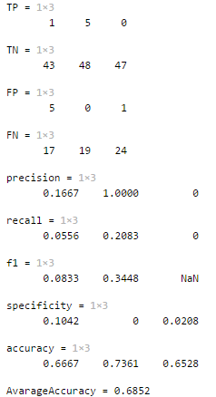

**Approach 2 - 2019_04_05_12_59**

**Network:**

Transfer learning from AlexNet changing last 3 layers.

|  |  |
| --- | --- |
| **Training parameters:**   * folds=3; * miniBatchSize = 64; * learningRate = 1e-4; * maxEpochs=230; * optimizer='sgdm'; * "L2Regularization",1e-04 * "Momentum",0.889 | **Dataset:**   * nSlices=6; * gap=2; |

**Results:**

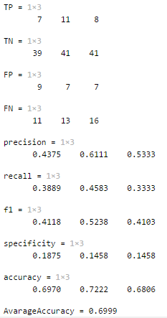

**Approach 3 - 2019_04_07­_14_41**

**Network:**

Transfer learning from AlexNet changing last 3 layers.

|  |  |
| --- | --- |
| **Training parameters:**   * folds=3; * miniBatchSize = 32; * learningRate = 1e-5; * maxEpochs=100; * optimizer='sgdm'; * "L2Regularization",1e-04 * "Momentum",0.889 | **Dataset:**   * nSlices=6; * gap=2; |

**Results:**

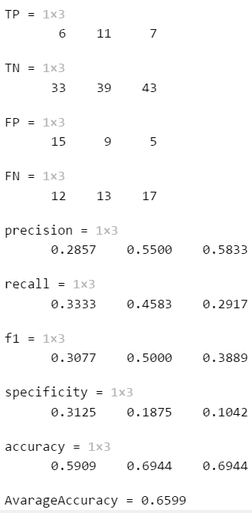

**Approach 4 - 2019_04_07­_16_17**

**Network:**

Transfer learning from AlexNet changing last 3 layers.

|  |  |
| --- | --- |
| **Training parameters:**   * folds=3; * miniBatchSize = 32; * learningRate = 1e-5; * maxEpochs=150; * optimizer='sgdm'; * "L2Regularization",1e-04 * "Momentum",0.889 | **Dataset:**   * nSlices=6; * gap=2; |

**Results:**

